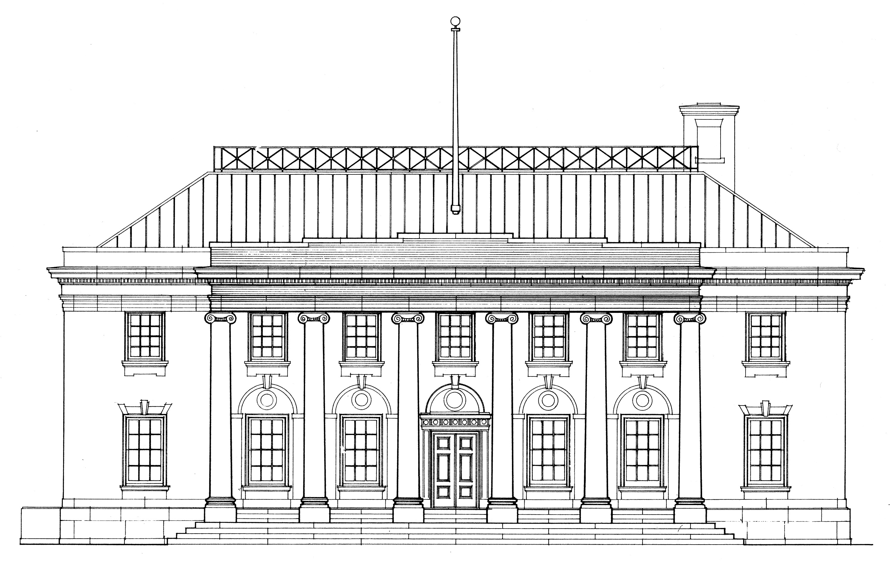

Rourke Art Museum
Facility Rental Application

Renter ________________________________________________________________________________________

Address ________________________________________________________________________________________

________________________________________________________________________________________

Contact 1 _______________________________ Contact 2 ________________________________

Phone _______________________________ Phone ________________________________

Email _______________________________ Email ________________________________

Event Date ____________ Type of Event _________________ Est. Attendance ____________

Space Request (check all that apply): Museum Interior _________ Museum Courtyard ___________

Event Coordinator _______________________________________________________________________________

Caterer _______________________________________________________________________________

Musician _______________________________________________________________________________

Florist _______________________________________________________________________________

Rental Company _______________________________________________________________________________

Equipment Needs Tables # _____ Chairs # _____ Other ________________________________________

How did you hear about using the Rourke Art Museum for your event?

Caterer/Event Planner _____ Word of Mouth _____ Internet _____

Previous Event ____ Other ___________________________________________

Renter Signature ____________________________________ Date ________________________

Print Name ___________________________________ Staff Initials ____________________

To reserve the facility for the date specified above, return this application by email to museum@therourke.org or by USPS to Rourke Art Museum, 521 Main Avenue, Moorhead, MN 56560.

